Annual Complaint and Customer Feedback Report 2021-2022
- Background and Context
This report covers the period from 01 April 2021 to 31 March 2022 (the reporting period) and looks at the number of formal complaints and compliments received during this period. If an informal complaint is raised the Groups policy is to seek to resolve these issues at the first point of contact.
The annual trend in formal complaints raised over the last few years is as follows:

2021/22 registered a rise on the previous year in terms of Stage 1 complaints (55 compared to 46) but was comparable with previous years. Stage 2 total complaints remain in a similar range, with 4 registered in the year – although this includes 1 “appeal” which remains outstanding as it is being looked at with complainant to see if a satisfactory solution can be arranged without it having to go to the Stage 2 Appeal Panel. Note that totals are not listed in this chart for earlier years as that data was not available.
It should be noted that these volumes represent formal complaints, and trends can be impacted quite substantially by the ability of staff and complainants to handle matters informally i.e., previous years may show a lower formal total, but this may be due to more matters being resolved successfully in an informal way.
It is also true that we, and the Housing Ombudsman, are seeking to make it easier for tenants to complain, should they need to do so. As such an increasing volume (as and when they occur) is not necessarily a bad thing and may represent success in publicising the routes tenants have available to complain.
Finally, for context when looking at the historic volumes above it is necessary to consider the following:
- 2017/18: 62 formal complaints logged – a peak in complaints appeared following the ability for customers to make a complaint via the form being available on the Group’s website.
- 2020/21: The majority of this financial year was during the height of the Covid pandemic’s start in the UK so this may have had some impact on volumes when compared to a more “normal” year.

- Policy Review and Changes to the Process
As at April 2022, we have just completed the most recent edition of the Housing Ombudsman’s “Complaint Self-Assessments Form”, which landlords are required to complete and publish annually (and follows on from its launch in 2021/22). This year’s changes come into force from 1 April 2022 and require alignment with the Code by 1 October 2022 and were summarised by the Ombudsman as follows (taken from slide pack shared on link further down in this section):
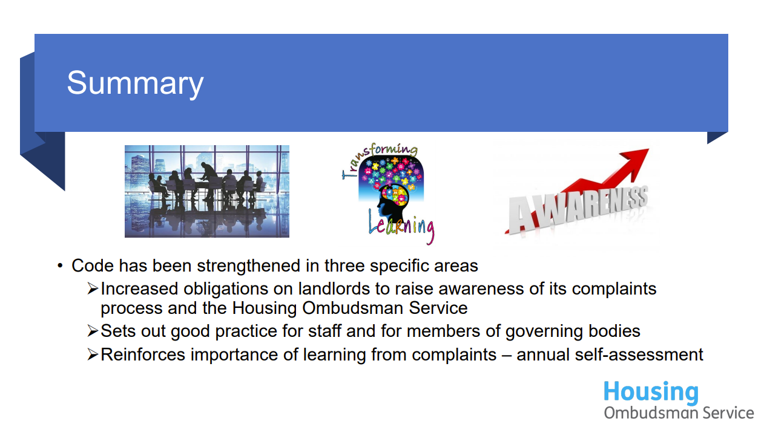
Any changes to be made to our existing complaints policy will be made subject to the self-assessment prior to the Housing Ombudsman deadline 1st October 2022.
Best practice ‘should’ requirements have identified the following actions:
- Code Section 2.2 - Where a landlord has set up channels to communicate with its residents via social media, then it should expect to receive complaints via those channels. Policies should contain details of the steps that will be taken when a complaint is received via social media and how confidentiality and privacy will be maintained.
We will accept a complaint through any communication channel, and they are processed in the same way regardless of channel used. We will update our policy to make this more explicit.

- Code Section 4.9 - Communication with the resident should not generally identify individual members of staff or contractors.
We tend to use role and names in communication to be transparent and clear, however, this is usually because as a small association the customer already knows the member of staff directly. Where an employee didn’t need to be named, we would not include their name in any response.

- Analysis of Complaints received for 2020/2021

3.1 - Stage 1 Complaint (Volumes & Performance)
Broken down on a month-by-month basis, there were periods when the number of Stage 1 volumes spiked somewhat (with 8 registered in February, the highest for the year) but this was not outside of what may be expected.

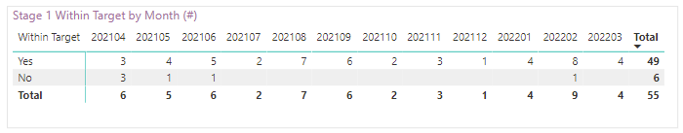
Q1 and Q4 were the busiest periods with 17 Stage 1 complaints raised in both, while Q3 saw only 6. That quarter did include the period approaching Christmas and New Year closure so this may have had some impact on the issues coming in.
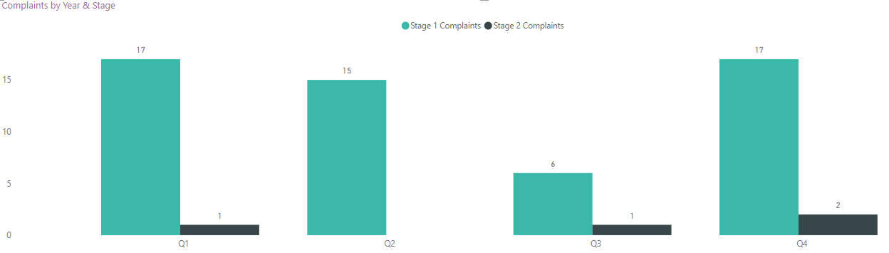
As to overall performance in terms of responding to the complaint within target time (10 working days) there was a significant improvement after Q1, and in the 9 months remaining only 1 complaint went out of target, this was with tenant approval and advanced notice of the reasons why additional time was required so within policy.
Overall, we saw an 89.09% of complaints responded to within target (and if we looked only at the final 3 quarters – 97.37%) which was up from 56.52% in 20/21.
While performance in Q1 was disappointing, work was done with the investigating managers and the complaints team to better identify likely delays and the improvements have been obvious. The strong end to the year provides confidence in the changes that have been made.
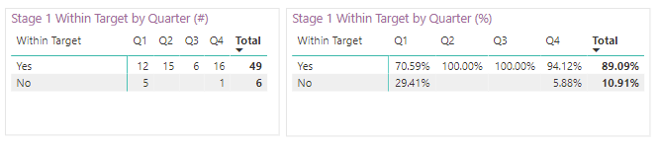
3.2 - Stage 2 Complaints (Volumes & Performance)
Broken down on a month-by-month basis, the 4 appeals came in during May, November and February. There was also one relating to a 20-21 complaint, but which did not reach us until April 2022 as a result of the tenant not having chosen to reach out to us until that stage (this does not currently show in the figures below).
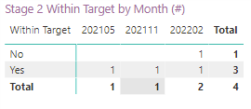
Performance for the year shows as 75% below but is actually 100% in reality. The one outstanding appeal (3288) is a case where the tenant has agreed with Prima to allow us to take some interim actions to see if we can resolve their concerns prior to proceeding with any appeal. In the event the tenant decides to progress, we will re-start the clock and aim to provide the response within the usual timescales. At the time of writing (27/04/22) this remains active.
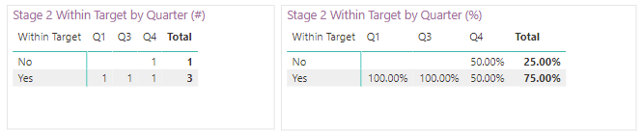
The appeals related to the following:
- 3288 – Ongoing “appeal” that is at the time of writing on hold as Prima have offered a visit from a senior member of staff to inspect the property and tenant’s request. Relates mainly to Energy Efficiency Ratings for the home (which tenant feels are below requirements) and customer service (in terms of response to Stage 1 complaint).

  - Stage 1 was not upheld and we await any stage 2 progression in consultation with the tenant.

- 3263 – Issues with the several different dates tenant was given for the planned replacement works in her kitchen.
  - Stage 1 was upheld, as was the Stage 2. Acknowledgement that mistakes were made in providing dates on when planned works in the kitchen were due and there had also been failures in communication elsewhere – including in the Stage 1 complaint when the Investigating Manager had not made a phone call within 2 days of the complaint being raised as per our processes.

- 3101 – Issues with several repair matters (with focus on leaks from roof and bathroom) and dispute over what Prima say they did to resolve them and tenants own view.
  - Stage 1 was partially upheld but stage 2 was upheld as it was felt that the initial response did not address all items contained within it.

- 2922 – Issue with decision and delay in giving decision, on the fitting of an external aid.
  - Stage 1 was not upheld but stage 2 was upheld as it was felt that the issues with communication (including a technical fault with the mobile app) warranted such an outcome. Accommodation was made around the aid that proved satisfactory to both parties, even though the decision originally made was within our policies (and so was not a failure).
In addition to those above, there was also an appeal that came in during 2021-22 (April) but which related to a complaint from 2020-21 (Nov). The tenant did not appeal the matter upon the Stage 1 outcome being shared, but did subsequently approach the Housing Ombudsman. The Ombudsman approached Prima and requested we progress to Stage 2 of our process, which we did. Regular contact was made with the Ombudsman even though this was not an investigation as such – given it had not exhausted our process – and confirmation provided once the Stage 2 decision was shared.
- 3132 – Issue with Prima’s decisions around planned kitchen replacement and dispute over dates.
  - Stage 1 was not upheld, while Stage 2 appeal was partially upheld as there were some points on the initial response that the Panel felt were not addressed appropriately. However, the main issue regarding the kitchen replacement date was not upheld as it was felt Prima had acted in line with our policies.
3.3 - Formal Complaints (by Landlord)
The majority of formal complaints raised were for PHA tenants (75%) compared to those of LCH (18%). This is comparable to the previous year were volumes followed a similar percentage split so there has not been any significant change in this regard. With the changes to Prima’s structure from 1st April 2022, we would expect this would be the last time we focus on split by landlord in terms of PHA and LCH, although there may remain demand to see numbers broken down by geographical area in some way. A further 7% of complaints were received from non-tenants and as such they are not indicated in the % split by landlord shown below.

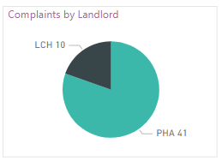
3.4 - Formal Complaints (by Categories & Outcome)
Repairs remains the primary reason for formal complaints with over half of all complaints having a repairs element to them. Adding on the Contractor category – which in most cases relates to a repair - increases this percentage further. It should be noted however that this will not all be day-to-day maintenance issues, as complaints about compliance, cyclical or programmed works are often added into the “Repairs” category when complaints are raised on QL.
It is to be noted that on many occasions there is a cross-over in the category of complaint, e.g. a complaint about a repair could also relate to a contractor. In these instances the complaint will be allocated to the most appropriate Manager. On occasions some formal complaints may remain assigned to the I&I Team rather than being allocated to an investigating manager, this is usually where a complex complaint cuts across several business areas and requires a co-ordinated approach to complete the response.

Complaints are broken down internally into the following categories:

- Repair: a complaint relating to outstanding repairs or to repairs to a property.
- Home: a complaint relating to a customer’s home in terms of a compliance issue, or within communal areas for flats etc.
- Contractor: a complaint relating to a contractor.
- Staff: a complaint relating to a member of staff.
- Service: a complaint relating to a failure in service provided by the Group.
- Tenancy: A complaint relating to the management of a customer’s tenancy.
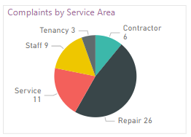

The complaints by outcome and service area are shown below:
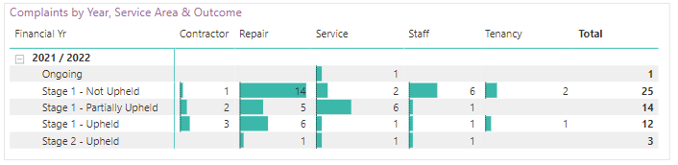
Overall, the highest % was for not upheld at 45.45%, with partially upheld at 25.45% and upheld at 21.82% (with another small % for those that reached Stage 2).
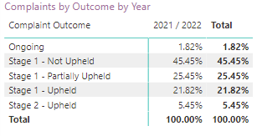
- Complaints Trends
The majority of complaints reported in this period have been relating to Repairs (26) these equate for 47.3% of the overall complaints received during the year.
This trend is common for housing associations as it is one of the service areas where customers are more likely to engage with us and also a service that is most important to our customers.
Looking at trends across the year, the main trend from complaints is relating to communication, focusing mainly on the below points:
  - Delays or failure of contractors reporting back to Prima and/or customers on follow-on works or outcomes of visits.
  - Failure Contractors informing Prima and/or tenants if they will be late for an appointment or need to re-schedule (i.e. staff sickness)
  - Prima staff not contacting customers back within expected timescales or closing QL contacts without notes on next steps (to assist colleagues on future queries).
We also track informal complaints from customers, where they call requesting an update or they have to call back about an issue, these follow the same trend as the formal complaints.

- Lessons Learnt (Complaint Specific)
“Lessons Learnt” are tracked in QL upon completion of a complaint case by the Investigating Manager or Complaints Team where there are lessons to be learned.

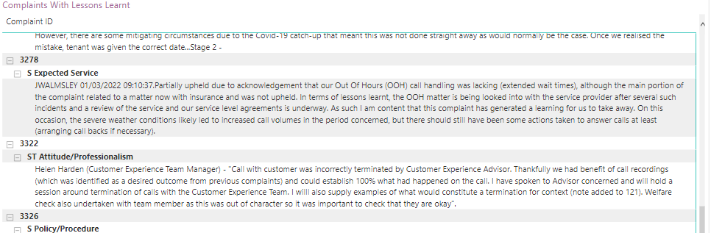
Some takeaways from the complaints handled in the period include:
- Re-introduction of call recordings can be very beneficial in allowing us to better support colleagues and customers (provides ability to understand what was / was not said on a call). Handful of complaints regarding staff advice and/or customer service were no concrete determination could be made due to not having recordings.
- More focus on ensuring tenants have electric and gas meters that can easily be registered upon sign-up.
- Clarity on the correct termination procedure for calls with customers that become abusive or uncooperative. Warnings should be given and terminations handled via an agreed upon process – and only as a last resort.
- Review of out of hours call handling service is necessary to ensure contracted service level agreements are being met i.e. time to answer calls, and that emergency calls in the evening and weekend periods are being answered promptly.
- Importance of informing customers of changes or adjustments to planned work programmes. Occasions were information shared previously has become redundant due to changes i.e. Covid pushing back works, but customers only found out upon contacting Prima.
- 2-day phone call from Investigating Manager on formal complaints (Stage 1) was not taking place in 100% of cases. This led to a couple of complaint escalations which could well have been avoided if the call had taken place. More focus on ensuring this is done on every occasion, this is now being tracked.

- Service Improvements (General)
In addition to those improvements identified within complaints themselves, the following are worth mentioning in terms of the wider handling of complaints in general.
- Re-Introduction of Call Recording: In the past few months we have been able to re-introduce the recording of calls (after a solution was implemented for taking card payments from tenants in a secure manner). This has already proven extremely valuable in the investigation of several matters and allowed us to be 100% sure of how a conversation(s) went.
- Customer Care Training - Group wide MGI training sessions have been held with all staff being requested to attend. These sessions (over multiple days) have focused on how we communicate with customers (and each other) and are part of a focus on improving how we work.

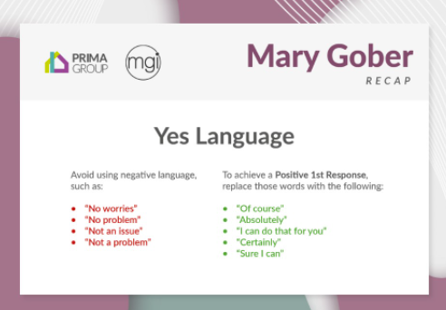

- Live Power BI report showing all current and historic complaints – Since Prima Group's complaint management moved into QL back in August 2019 we have been working on rolling out robust and informative live reporting but a complete solution remained over the horizon. However, during October 2021 we launched a new and improved Power BI report that provides a live view of current and historic complaints performance and has allowed us to remove the need for additional tracking in spreadsheets etc. This report is downloaded and shared with our Executive Management Team on a regular basis, in addition to being immediately accessible via Power BI itself.
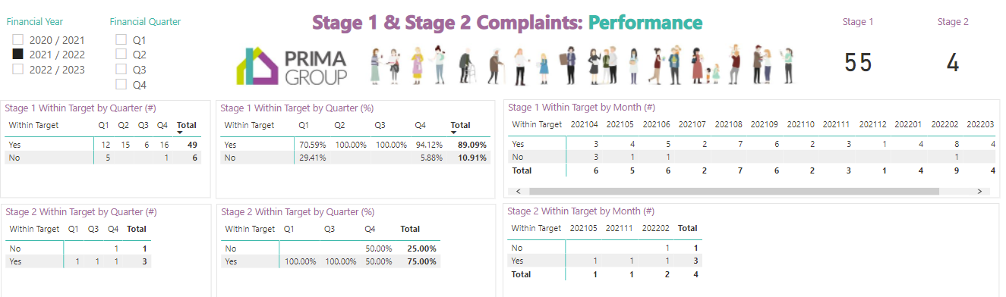

QL Actions Worklist Alerts Re-Enabled - Communication remains a driver for complaints (informal and formal) and improving our response internally to customer related requests is key. We have now re-enabled weekly automated alerts to staff reminded them on what remains outstanding in their QL Worktrays. This will hopefully assist in nudging colleagues to more regularly review and progress any actions they have been assigned.

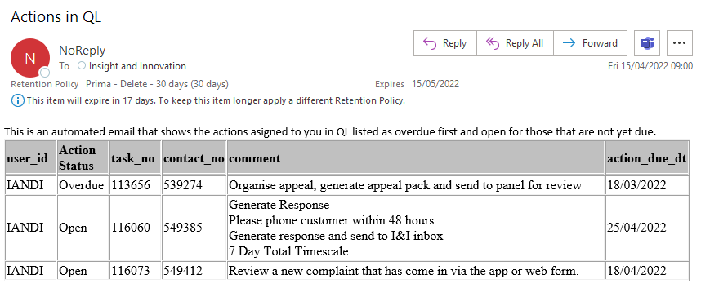

Root Cause Analysis Action Created - In October 2021 we also added in an additional action to our QL Complaint Management Process to stamp upheld and partially upheld complaints with pre-defined failure reasons. The idea being that we can then more easily identify trends via a matrix on our Power BI Complaints Report. These reasons cover several areas relating to Contractors, Staff and Service Delivery and may be subject to change as we start using the data, but should at least provide a quick headline of areas were we have identified our service offering has fallen short. At present this remains in need of work but as data builds up, improvements will be made.
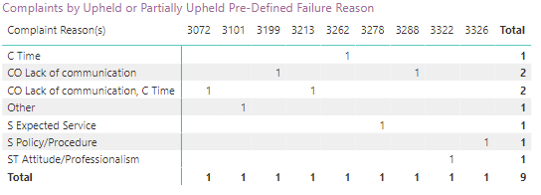
CX Customer Satisfaction Surveys – We introduced the CX Feedback solution in March 2022, this enables us to send out satisfaction surveys for a number of customer touchpoints, such as repairs and contact centre calls. Uptake from customers has been very good and will enable us to act on customer dissatisfaction much quicker reducing the risk of this escalating to a formal complaint stage.

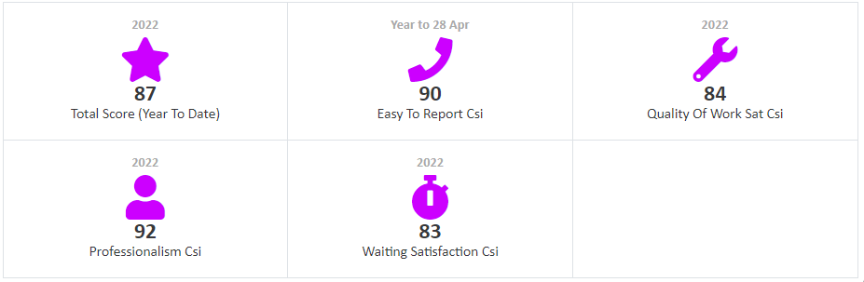

Additional “Fail Safes” on Mobile App and webform – On occasions some contacts had not flagged correctly to Prima via the expected route and had become “stuck” in the system (so to speak). ICT have since added in extra steps to ensure contacts are always routing through correctly, and to have added in additional safeguards so that a lack of traffic generates an alert (so the appropriate systems can be checked to make sure they are working as intended).

- Housing Ombudsman Contacts
While there was occasional contact with the Housing Ombudsman in 21/22, there were no complaints which reached a point of escalation (that we are currently aware of). The contacts we did had related to complainants who may have reached out to the Ombudsman prior to having either started or finished Prima’s formal complaints process. As such, they were either directed to do so, or Prima were contacted and asked to make contact with them (and progress accordingly).

- Compliments received for 2021/22
45 compliments have been recorded in the reporting year (down from 58 the previous year). It is unlikely that this is reflective of all compliments from people who have been in contact with us in the reporting year - in reality a large percentage will not be logged, particularly verbal compliments given directly from customers to staff members about themselves. Nevertheless, this is something we want to actively encourage the collection of.
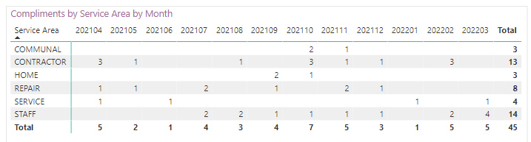
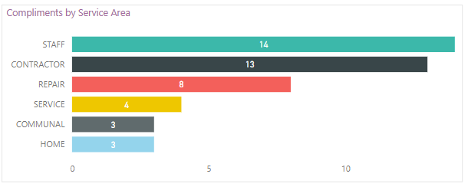

We aim to publish compliments on our Yammer page (as per example screen shot below) to provide wider visibility to the business and to remind everyone that logging these will ensure that their colleagues receive recognition for their hard work, to promote and embed a positive customer service culture.

- Conclusion
In conclusion, good progress has been made in our complaint handling processes, tracking and processing has improved as a result of customer feedback. A review of the new Housing Ombudsman’s Complaint Handling Code has been carried out and although we are compliant it has helped us identify a few areas where we could make further improvements and these will be carried out during the year.

